 |  | 
Digital Malawi Project transforming higher education through MAREN internet connectivity
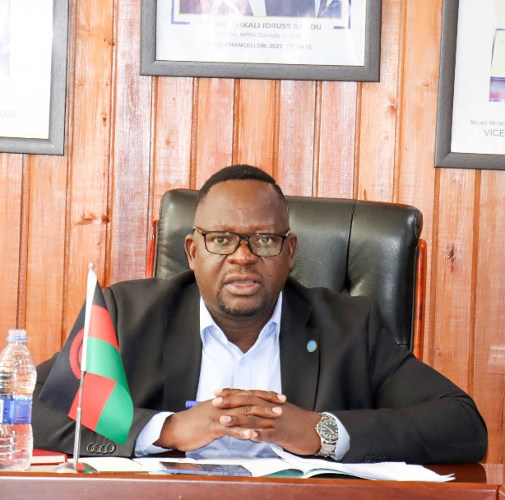  Namalomba: Internet is vital in institutions of higher learning | 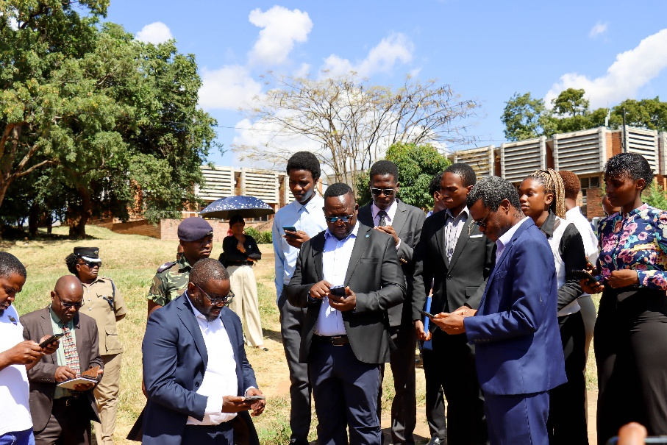  Namalomba and officials test internet connectivity during the visit.

Minister of Information and Communications Technology, Dr. Shadreck Namalomba, has commended the Malawi Research and Education Network (MAREN) for expanding internet connectivity to higher learning and research institutions, describing the initiative as a game-changer in the country’s education sector.
He made the remarks yesterday during a tour of the Malawi Research and Education Network (MAREN) facilities at the University of Malawi (UNIMA) in Zomba, one of the beneficiaries of the Digital Malawi Project.
Namalomba emphasized the critical role of reliable internet connectivity in improving the quality of education and research in institutions of higher learning.
“The Digital Malawi Project, through MAREN, is transforming lives because students can now access online learning materials, research journals, and other academic resources with ease. Gone are the days when accessing scholarly materials required spending huge sums of money on books or waiting for long periods. Today, with just a click, students and researchers can access the information they need,” said Namalomba.
The Minister further urged MAREN to ensure uninterrupted internet connectivity in order to sustain quality teaching, learning, and research services in universities and other research institutions.
He also encouraged MAREN to expand connectivity to remote schools across the country so that more learners can benefit from digital learning opportunities.
Speaking during the tour, MAREN Chief Executive Officer, Solomon Dindi, disclosed that under the new Digital Malawi Acceleration Project, the institution has been tasked with connecting 2,000 schools to free internet services nationwide.
Dindi added that MAREN has established a sustainable operational model through revenue generated from internet services provided to universities and other institutions.
Vice Chancellor of the University of Malawi, Professor Samson Sajidu, said the internet connectivity provided through MAREN is currently benefiting about 2,000 students residing on campus.
He added that while a few challenges remain, plans are underway to extend the service to students living off campus.
Through the Digital Malawi Project, MAREN received financial support and bandwidth capacity to strengthen internet service delivery to higher learning and research institutions nationwide.
Currently, MAREN is serving 84 higher learning and research institutions with advanced internet connectivity, increased bandwidth, and enhanced value-added services aimed at improving learning, teaching, and research standards in Malawi.

