 |  | 
MACRA, PPPC engaged Stakeholders on USF facilities licensing ahead of tower rollout
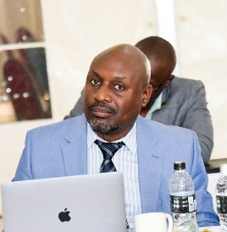  Mankhambo: We will call for bids soon | 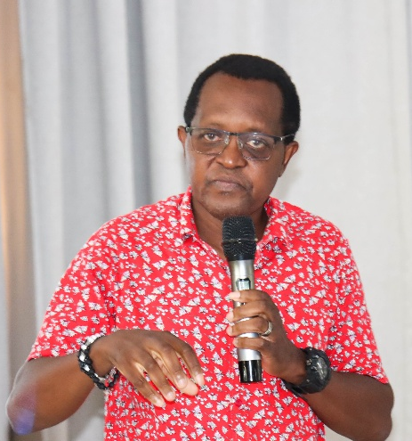  Matemba: DMAP is accelerating digital transformation | 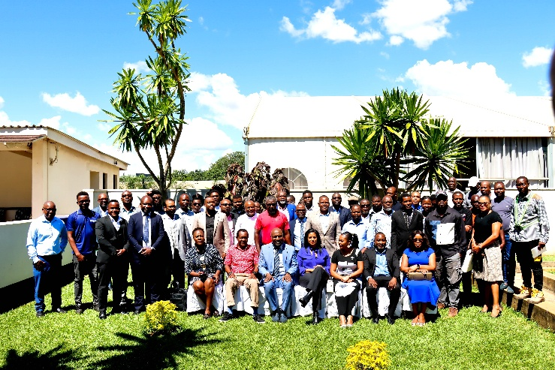  All Participants pose for a group photo after the meeting.
Stakeholders in the telecommunications sector gathered in Lilongwe for a one-day Orientation on the Universal Service Fund (USF) Facilities Licensing Workshop, jointly organized by the Malawi Communications Regulatory Authority (MACRA) through its Universal Service Fund (USF) and the Public Private Partnership Commission (PPPC).
The workshop brought together potential investors and service providers with the aim of equipping them with a comprehensive understanding of licensing requirements and procedures for the upcoming USF Tower Installation Initiative.
The initiative will deploy 100 communication towers in rural and underserved areas to enhance digital connectivity, funded by the Digital Malawi Acceleration Project (DMAP).
Speaking during the session, MACRA Director of Broadcasting, Zadziko Mankhambo, emphasized that the orientation was designed to prepare stakeholders for the competitive bidding process.
“This workshop is intended to ensure that all participants and potential bidders fully understand the requirements needed to participate in the USF Tower Installation Initiative successfully,” he said.
Mankhambo further disclosed that MACRA, in collaboration with the PPPC, will soon issue a call for bids for the initiative.
He encouraged stakeholders to actively participate in the bidding process to enhance competitiveness and ensure the successful implementation of the initiative.
In his remarks, PPPC-DMAP Project Manager, Chimwemwe Matemba, highlighted that the initiative is central to accelerating Malawi’s digital transformation agenda, particularly by extending connectivity to hard-to-reach communities.
Matemba also guided participants through the key stages involved in the bidding process, outlining what is required for successful participation in the initiative.
Acting Head of USF, Khumbo Kasambara, outlined that the project will offer subsidies to all successful licensed bidders on a competitive basis.
Kasambara further revealed that approximately 89 percent of Malawians are currently within mobile broadband coverage, with efforts underway to extend connectivity to the remaining 11 percent of the population.
MACRA is expected to subsequently share license application forms, the license fee schedule, and detailed terms and conditions as the initiative progresses to the next phase.

