 |  | 
DMAP to enhance connectivity and government service delivery
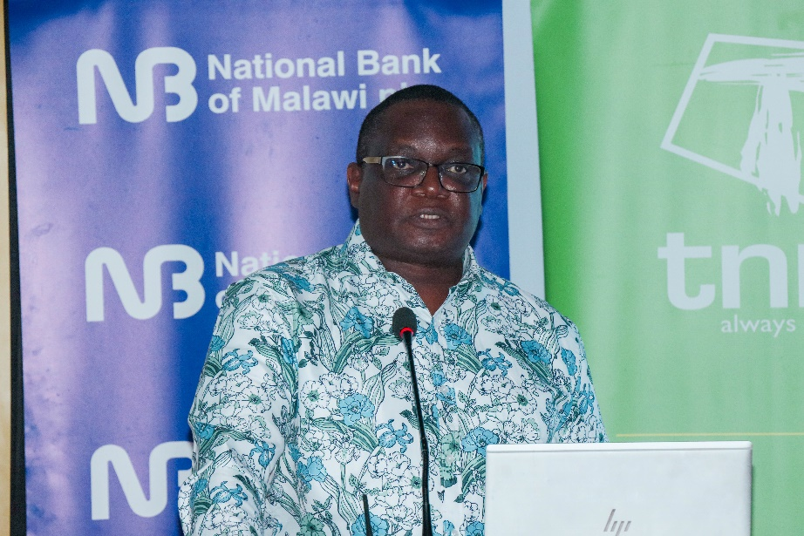  Kabambe: We will connect government institutions | 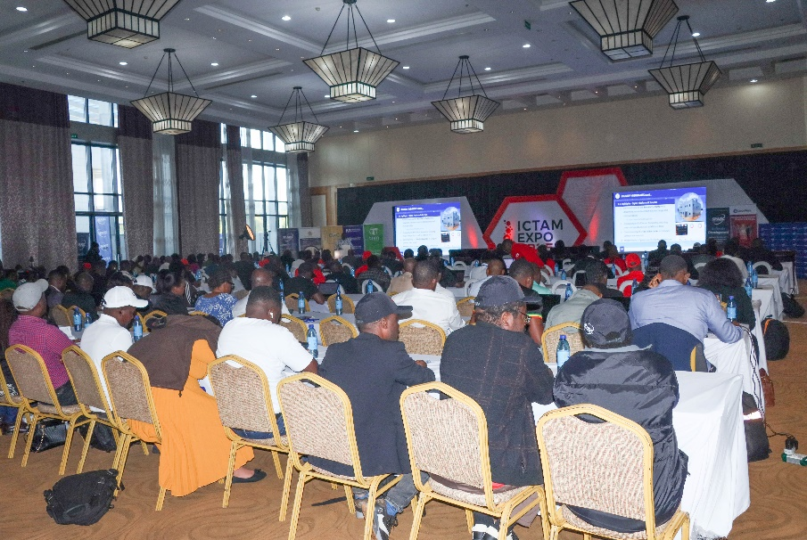  A cross-section of the expo

Malawi is poised to advance in its digital transformation journey with the new Digital Malawi Acceleration Project (DMAP), a successor to the Digital Malawi Program Phase 1: Digital Foundations Project.
The project is implemented by the Ministry of Information and Digitalization, in collaboration with the Public Private Partnership Commission (PPPC), with funding from the World Bank.
Speaking on Friday at the 2025 International ICT Expo in Lilongwe, PPPC CEO Patrick Kabambe said DMAP is aimed at building on the successes of the first project.
Kabambe pointed out that the project will extend last-mile connectivity to over 500 government institutions in rural areas and connect 2000 schools across the country through the Malawi Research and Education Network (MAREN), a dramatic scale-up from the 80 institutions covered in the first phase.
He explained: “We're going to provide continued support to the new data center in Lilongwe and enable cloud services at the national and regional levels.”
In a major development for digital governance, Kabambe announced that the National Registration Bureau will receive funding to introduce a Digital ID system.
“This will transform access to digital services. It will support secure identity verification for multiple sectors and enable e-KYC (Electronic Know Your Customer) services, improving efficiency and security across government and business transactions,” he said.
The project was recognized at the expo with the Internet Connectivity Award, recognizing its innovative approach to bridging Malawi's digital divide.

